聊天機器人

Chatbots

在此專案中你會訓練一個聊天機器人，他會依照選定的主題回答問題。

In this project you will make a chatbot that can answer questions about a topic of your choice.

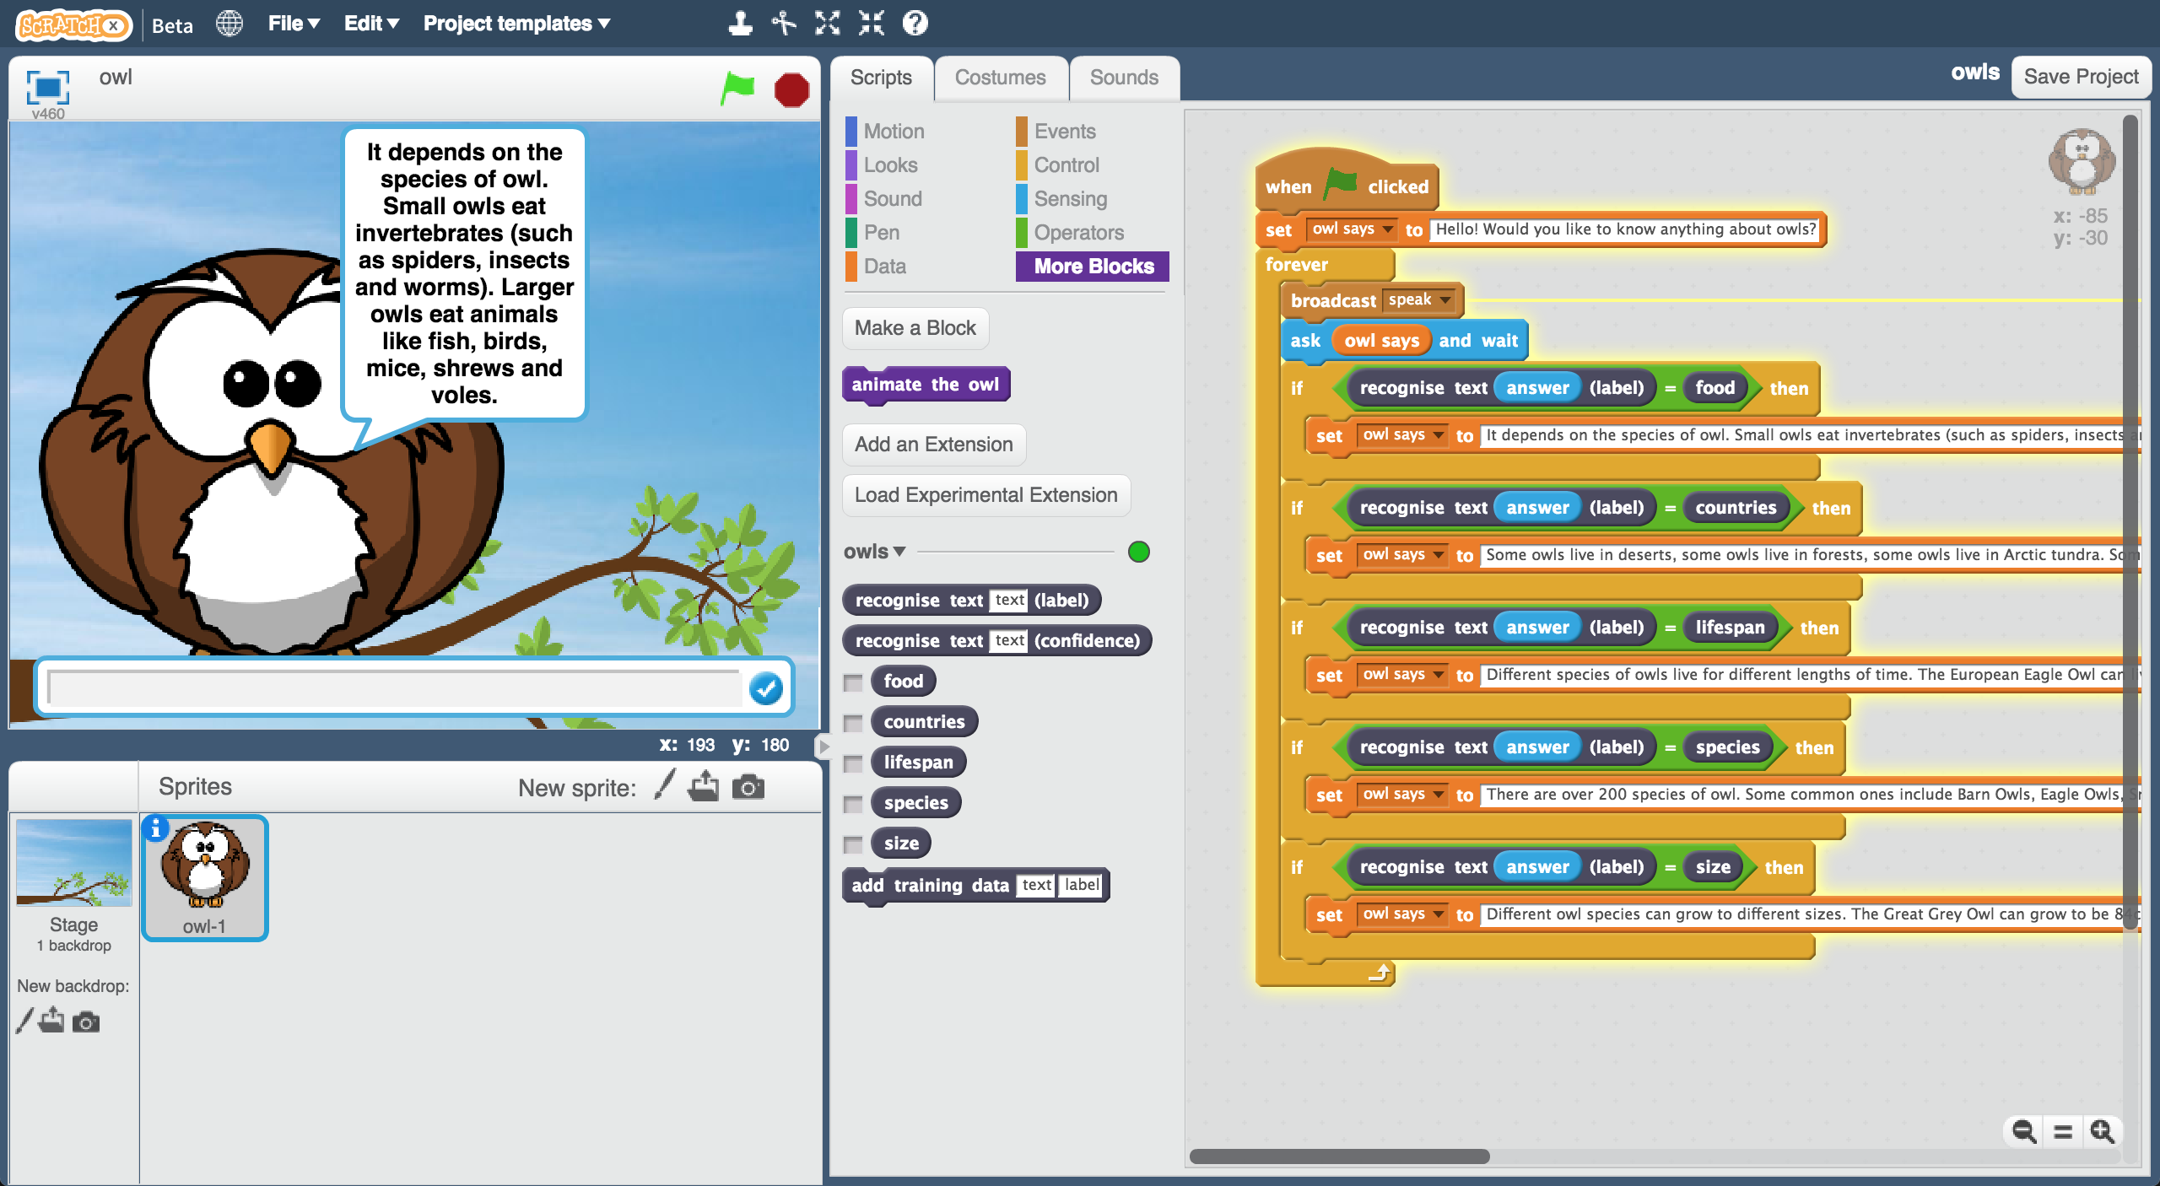

Creative Commons LicenceThis project worksheet is licensed under a Creative Commons Attribution Non-Commercial Share-Alike License

http://creativecommons.org/licenses/by-nc-sa/4.0/

1. 幫聊天機器人選定**一個主題**

要選擇你夠熟悉、可以正確作答的作為主題。

主題可以是一個地方（例如你居住的城鎮）、一種動物（老虎、恐龍）、一個組織（你就讀的學校）或是歷史相關的主題（維京人、羅馬人）等。

在這份學習單裡以**貓頭鷹 (owls)**當作範例

Decide on **a topic** for your chatbot  
Choose something that you know well enough to be able to answer questions about.   
*It could be a place (e.g. The town where you live?)  
It could be an animal (e.g. Tigers? Dinosaurs?)  
It could be an organisation (e.g. Your school)  
It could be something from history (e.g. Vikings? Romans?)  
For the rest of this worksheet, I’ll be using* ***owls***

1. 想**五個**跟主題相關的問題

以貓頭鷹為例，五個題目可以是：

*貓頭鷹吃什麼？(*What do owls eat?*)

*貓頭鷹住在哪裡？( *Where in the world do owls live?*)

*貓頭鷹可以活多久？( *How long do owls live?*)

*貓頭鷹有哪些品種？( *What types of owls are there?*)

*貓頭鷹可以長到多大隻？( *How big do owls grow?*)

Think of **five things** someone might ask about your topic  
*e.g. for* ***owls****, this could be:  
* What do owls eat?  
* Where in the world do owls live?  
* How long do owls live?  
* What types of owls are there?  
* How big do owls grow?*

1. 搜尋網頁：<https://machinelearningforkids.co.uk/>

Go to <https://machinelearningforkids.co.uk/> in a web browser

1. 點選“**Get started**”按鈕

Click on “**Get started**”

1. 點選“**Log In**”按鈕並登入系統

*如果你沒有帳號，請你的老師幫你建立一個帳號。*

*如果你不記得你的帳號或密碼，請你的老師幫你重新設定一次。*

Click on “**Log In**” and type in your username and password  
*If you don’t have a username, ask your teacher or group leader to create one for you.  
If you can’t remember your username or password, ask your teacher or group leader to reset it for you.*

1. 點選上方清單中的 **”Projects”** 按鈕

Click on “**Projects**” on the top menu bar

1. 點選 “**+ Add a new project**” 按鈕

Click the **“+ Add a new project**” button.

1. 為你的專案命名，並設定成辨識 “**text**”類別，點

選 “**Create**”按鈕

Name your project and set it to learn how to recognise “**text**”.   
Click the “**Create**” button  
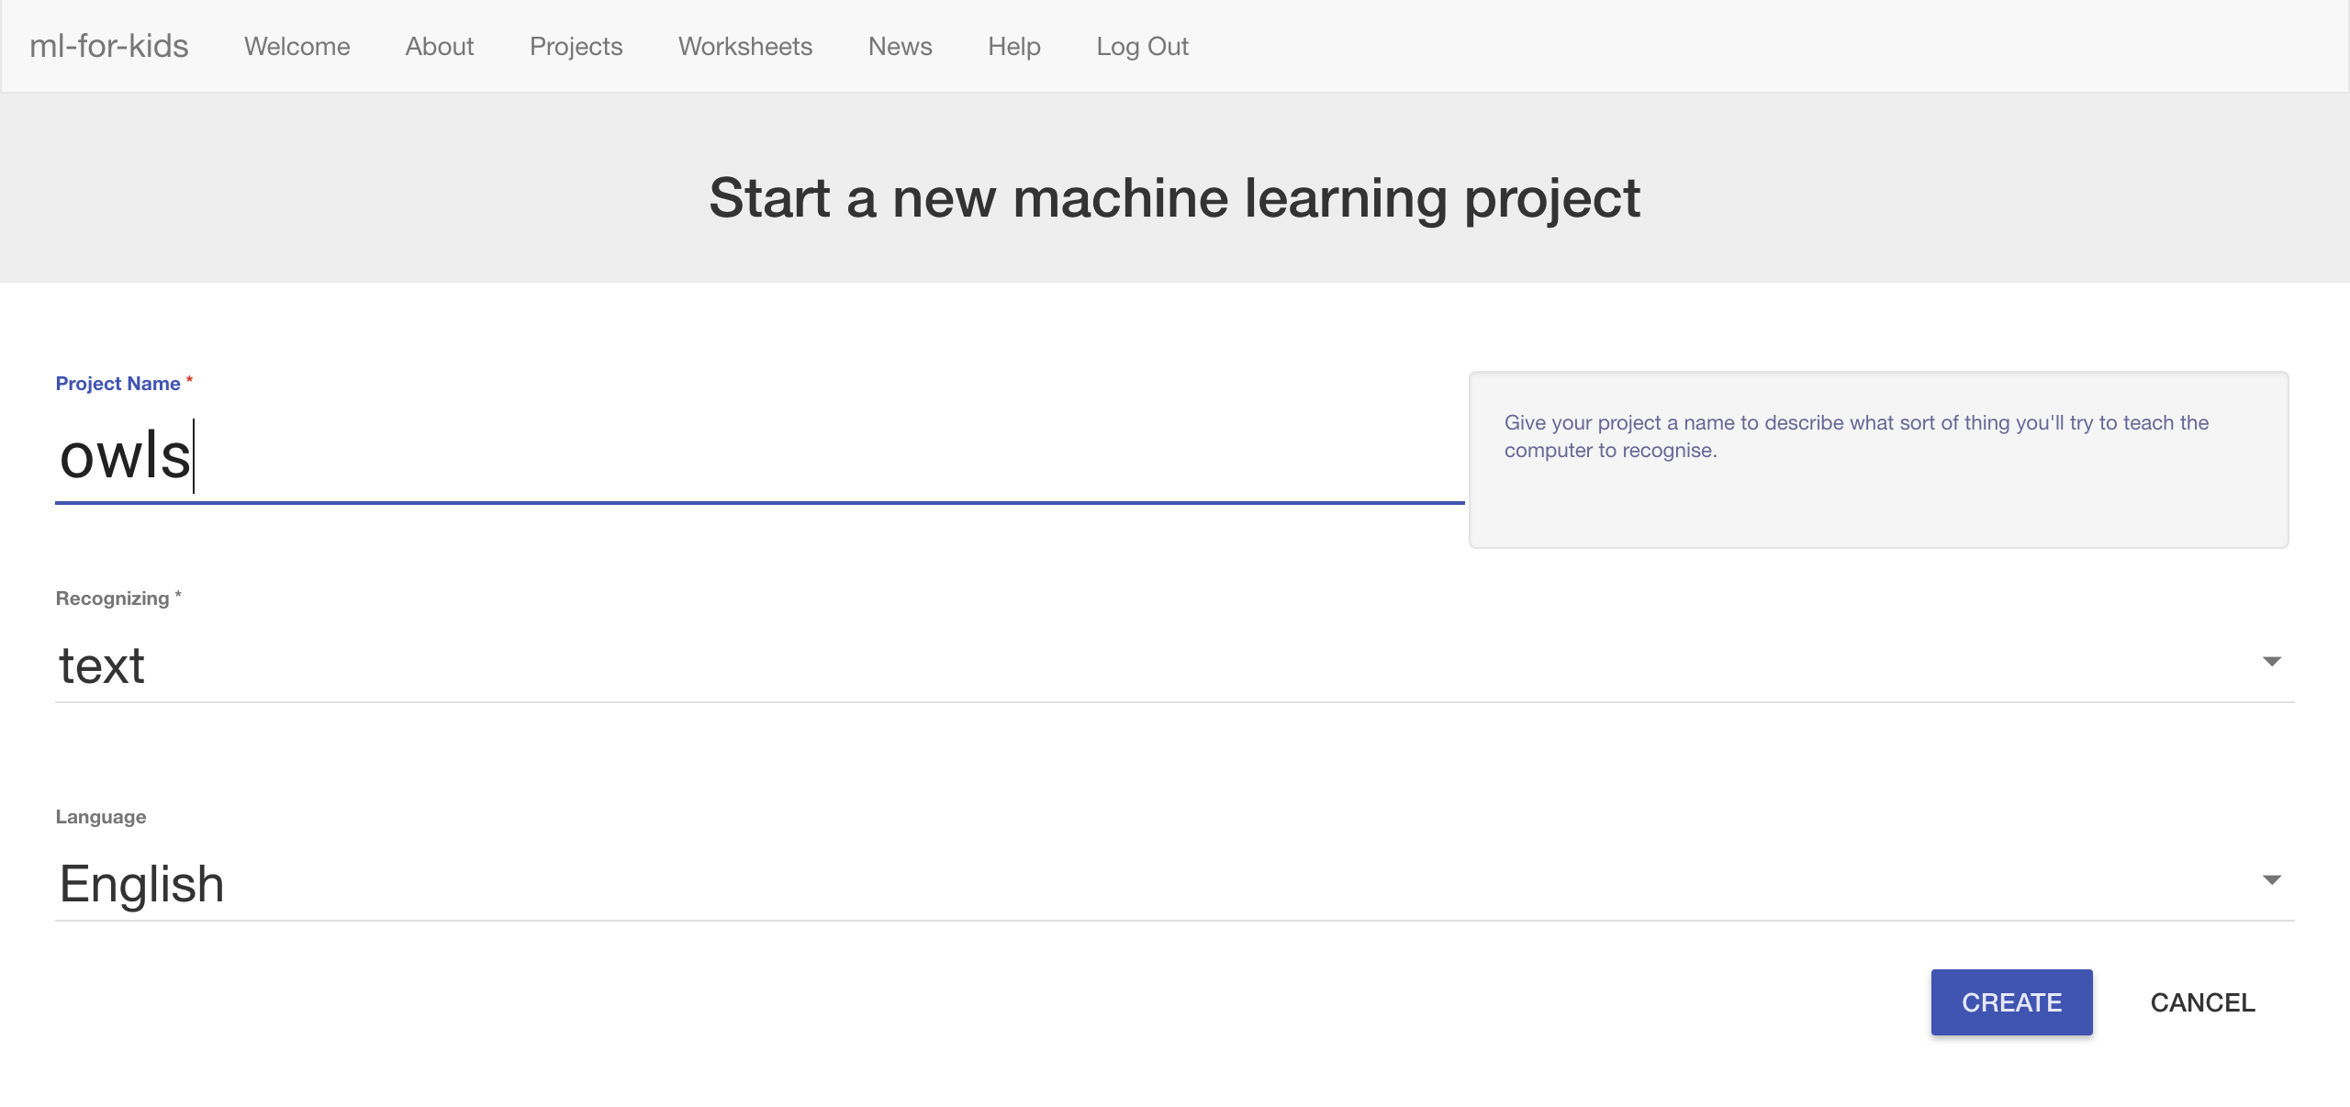

1. 點選專案清單中的新專案

Click on your new project in the projects list

1. 點選 **”Train”** 按鈕

Click the **Train** button.  
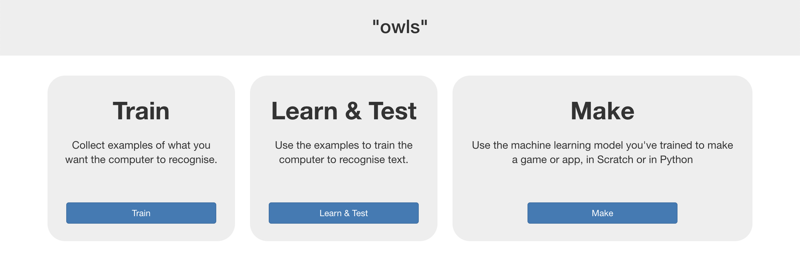

1. 點選 “**+ Add new label**”按鈕

Click the “**+ Add new label**” button  
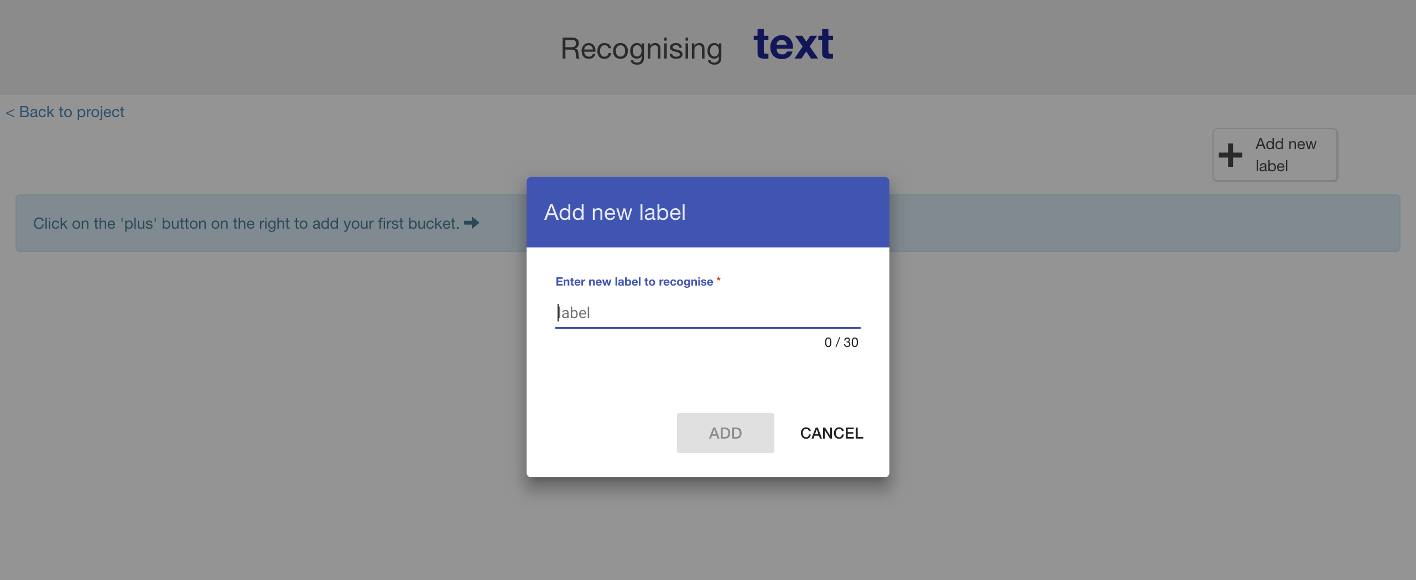

1. 在名稱欄位輸入一個可以用來代表步驟二裡問題一的名字

*例如：我使用food來代表“貓頭鷹吃什麼”這問題*

Type in **one word** that sums up the first of your things from Step 2, then click **Add**.   
*I used “food” to sum up questions like “What do owls eat?”*  
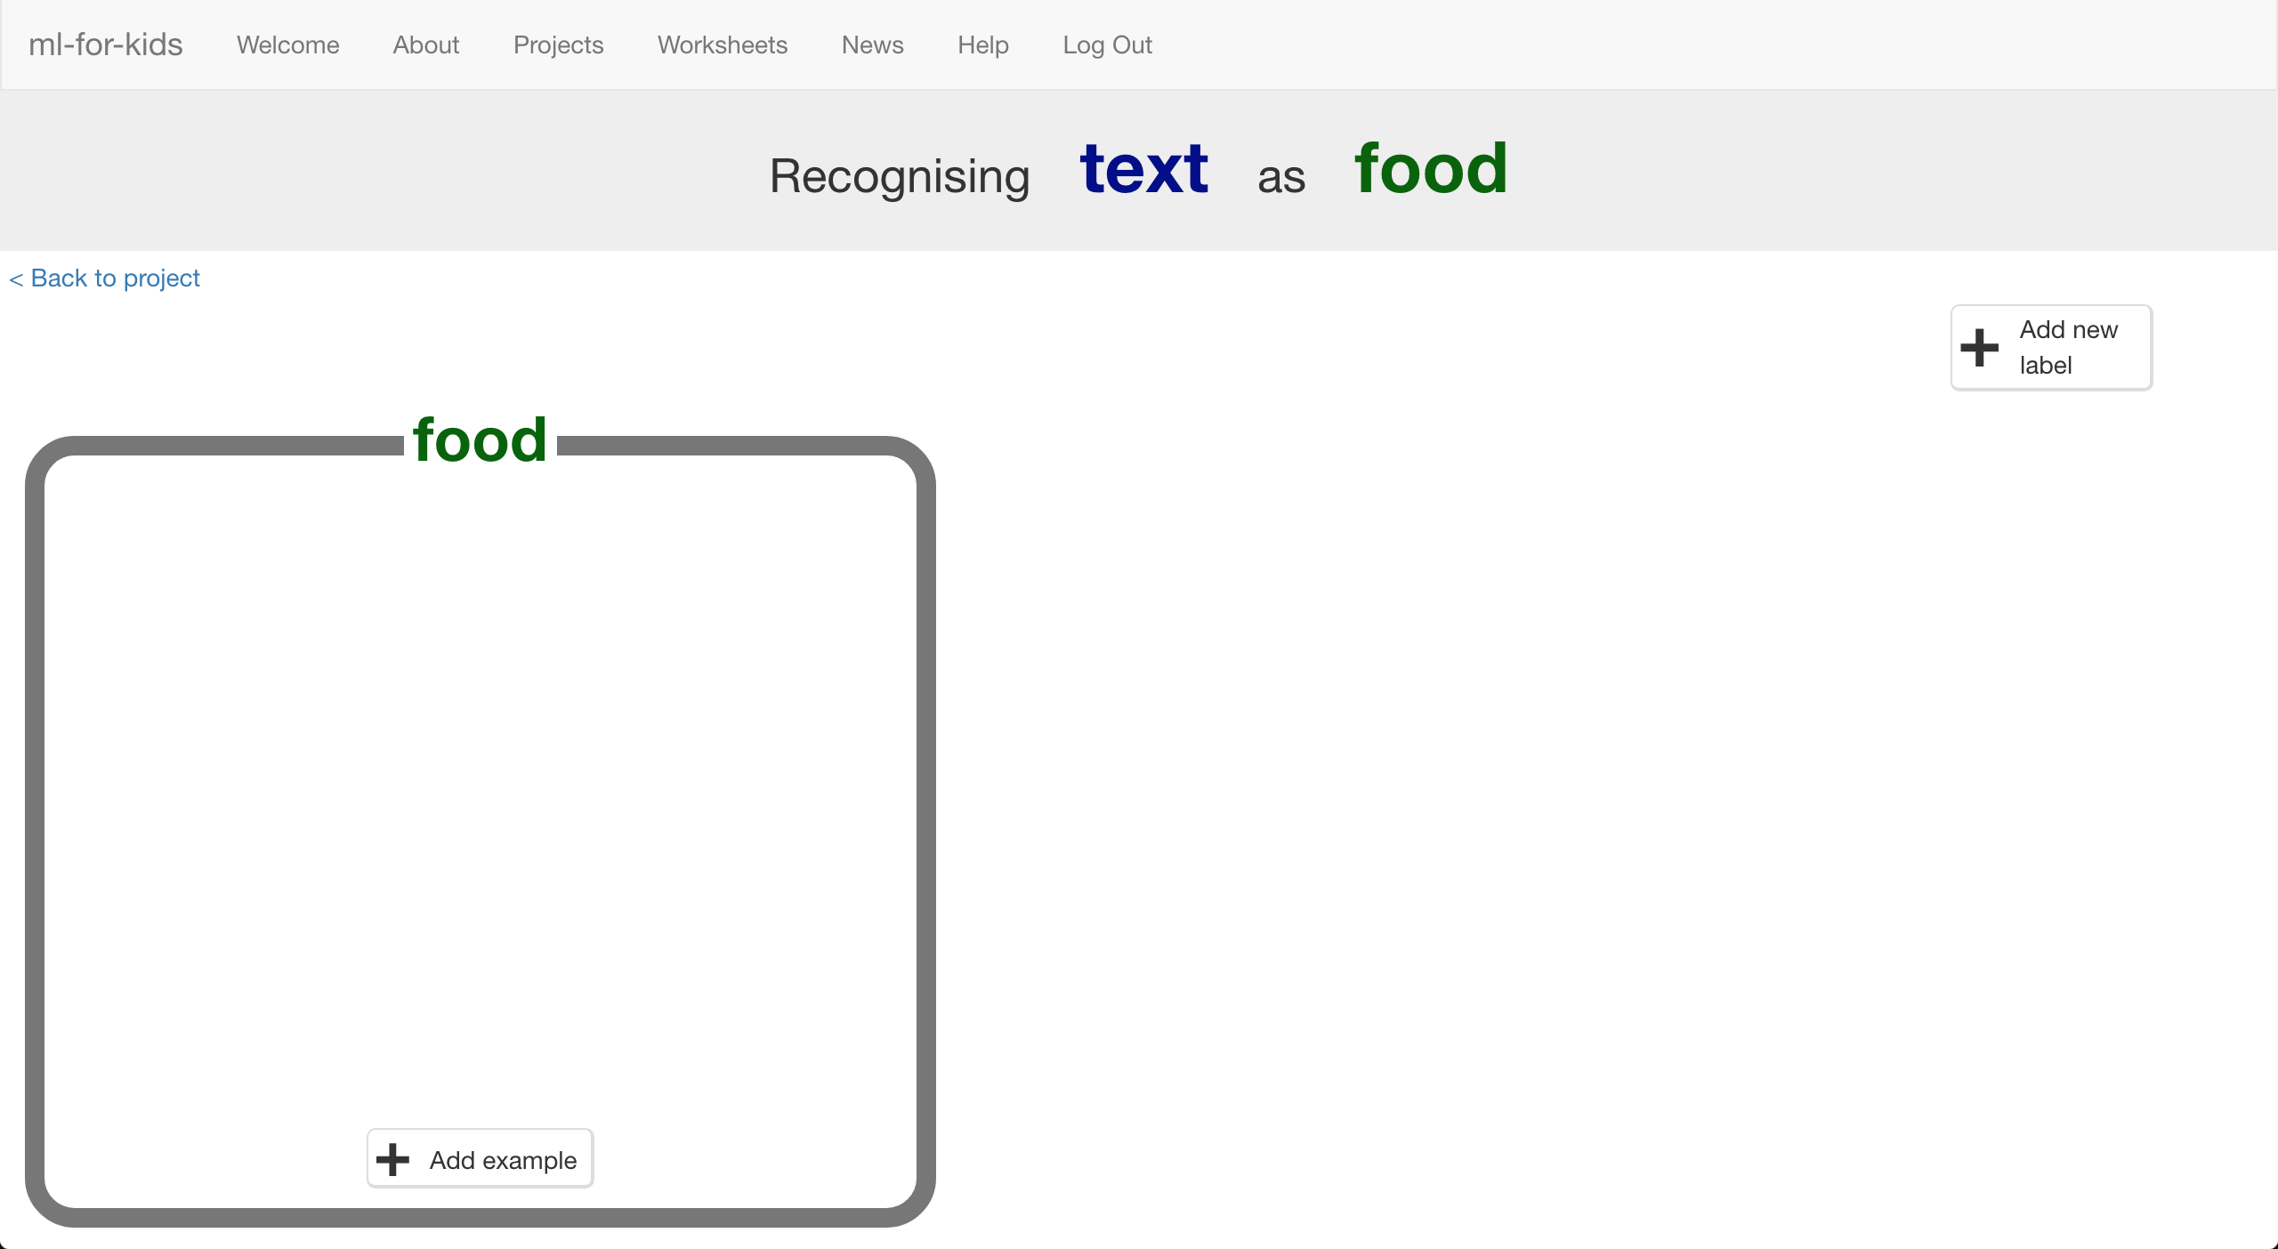

1. 重複上個步驟，幫步驟二中的所有問題都新增一個label

*取什麼名稱其實沒有很重要，只要你知道這些label各自代表什麼就行了*

Do that again for all of the things in your list from Step 2  
*The words you choose don’t really matter, as long as* ***you*** *understand what they mean.*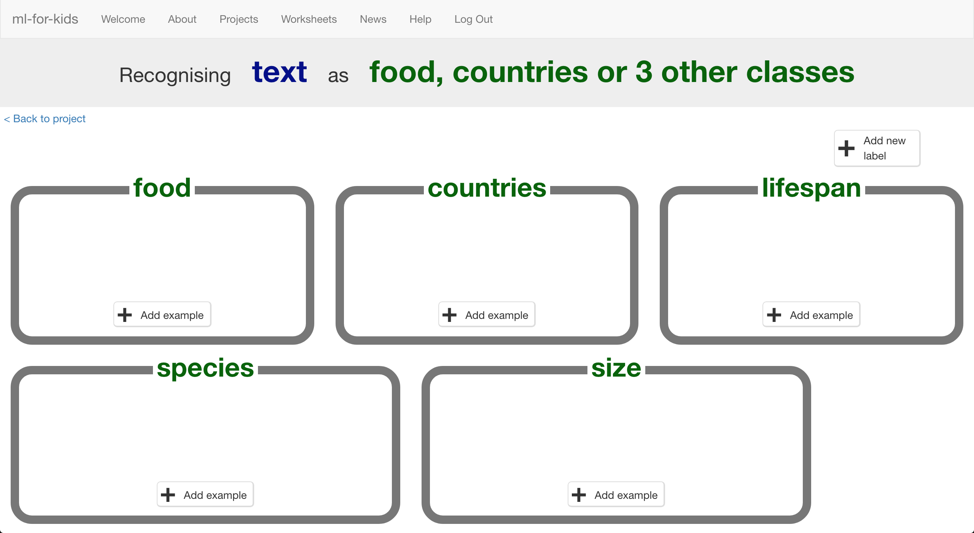

1. 點選其中一個方框中的“**+ Add example**”按鈕

Click the “**+ Add example**” button in one of the buckets

1. 輸入一個範例問句

Type in an example of how someone might ask that question  
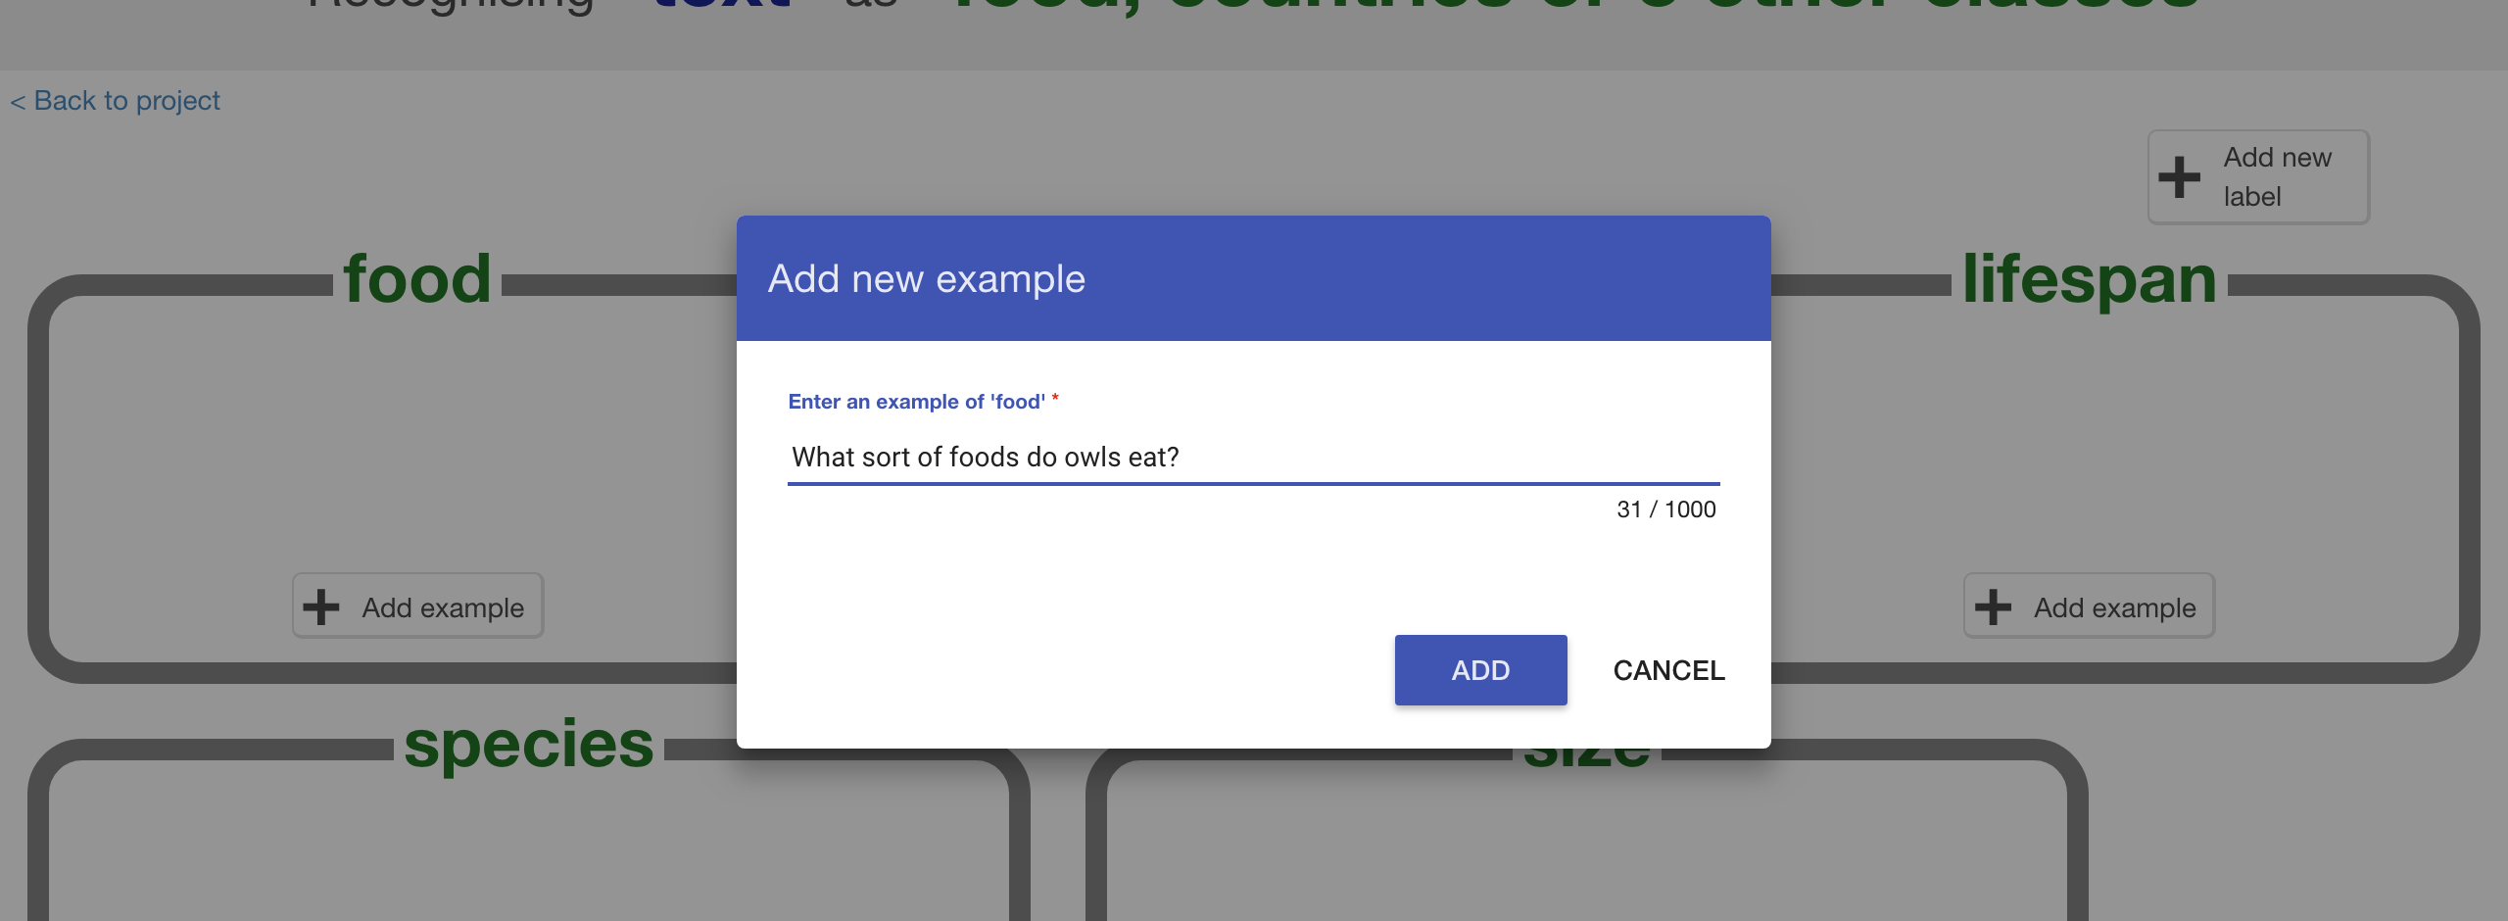

1. 點選“**Add**”

Click “**Add**”

1. 重複上述步驟直到此類別裡有**五個範例**

Repeat until you’ve got **five examples** of how to ask that question.  
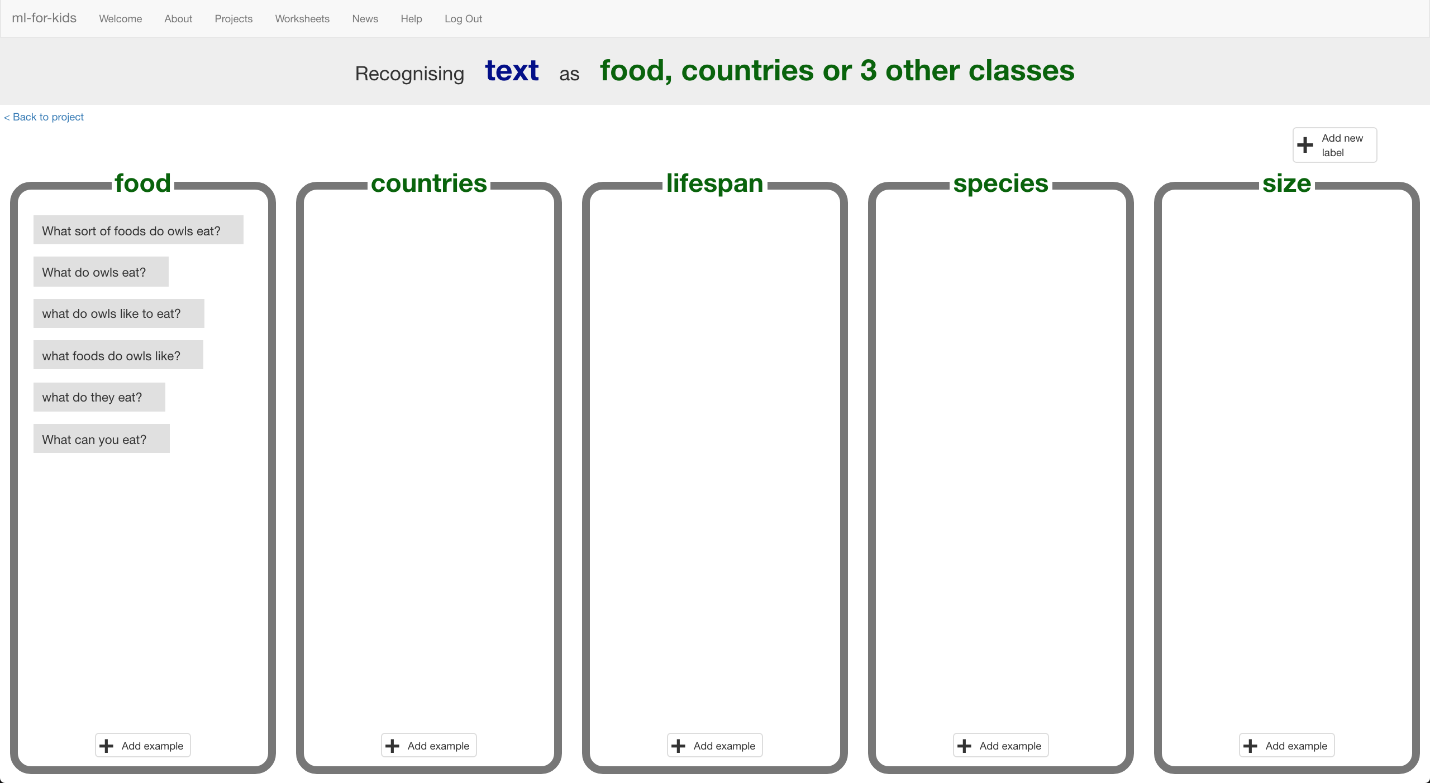

1. 重複前面的步驟，直到每個方框裡都至少有五個範例

Repeat until you’ve got at least five examples in every bucket  
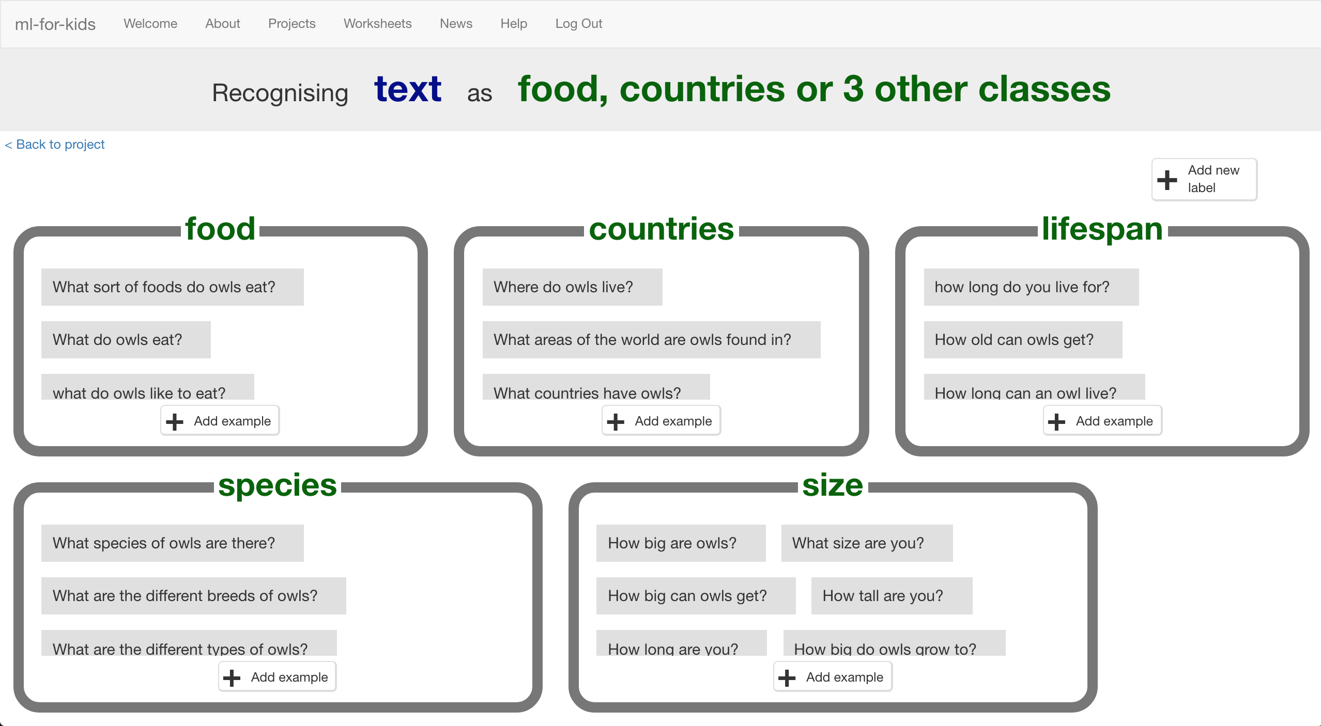

1. 點選“**< Back to project**”

Click on the “**< Back to project**” link

1. 再點選“**Learn & Test**”

Click the “**Learn & Test**” button

1. 點選“**Train new machine learning model**”

*只要你蒐集到夠多範例，電腦就可以開始從範例中學習辨別不同的問題*

Click the “**Train new machine learning model**” button  
*As long as you’ve collected enough examples, the computer should start to learn how to recognise questions from the examples you’ve given to it.*  
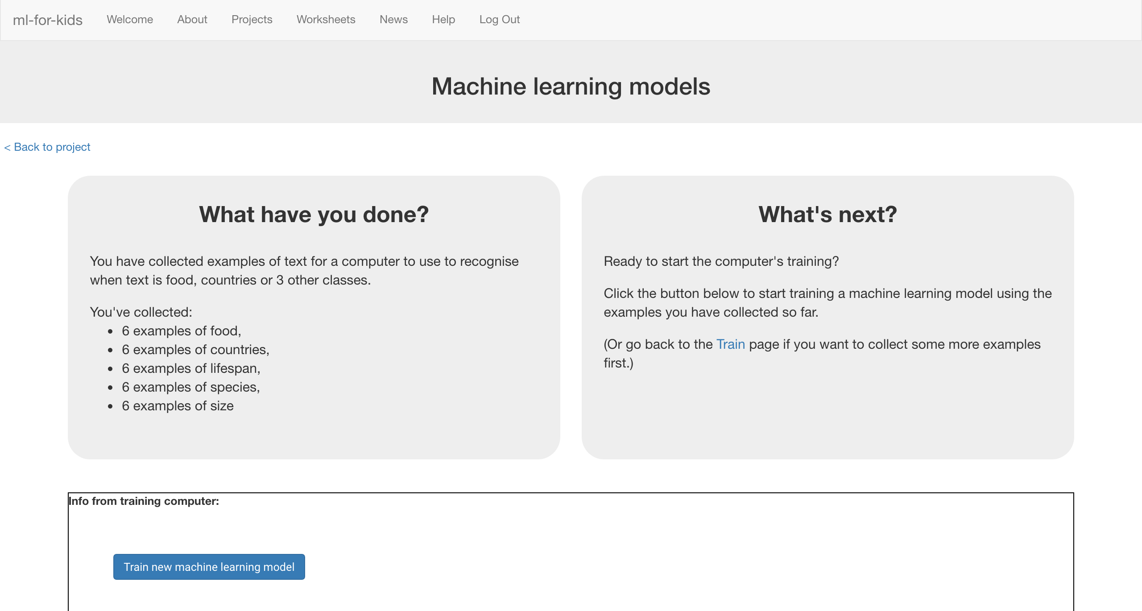

1. 等待訓練完成，這可能需要幾分鐘的時間

當狀態顯示*“Available”*代表訓練已完成

Wait for the training to complete.   
*This might take a couple of minutes.  
It’s finished once you see the “status” change to “Available”*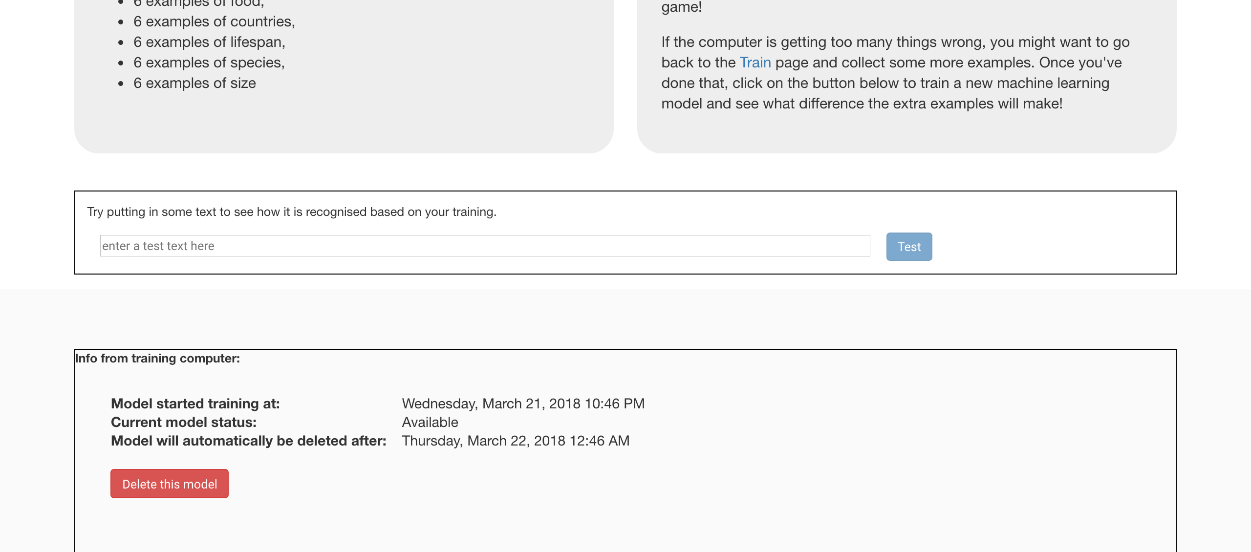

1. 點選“**< Back to project**”

Click the “**< Back to project**” link

1. 點選“**Make**”

Click the “**Make**” button  


1. 點選“**Scratch**”

Click “**Scratch**”

1. 點選“**Open in Scratch**”

Click the “**Open in Scratch**” button  
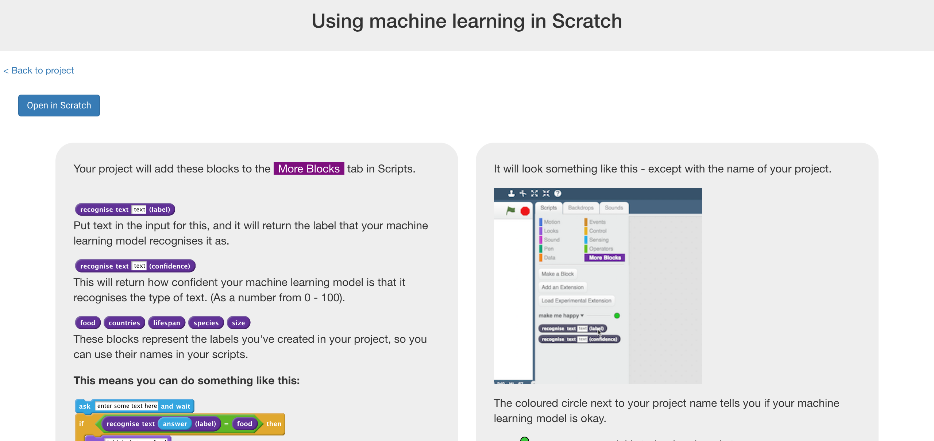

1. 點選“**Project templates**”，再點選“**Owls**”

Click “**Project templates**” -> “**Owls**” to open the project template  
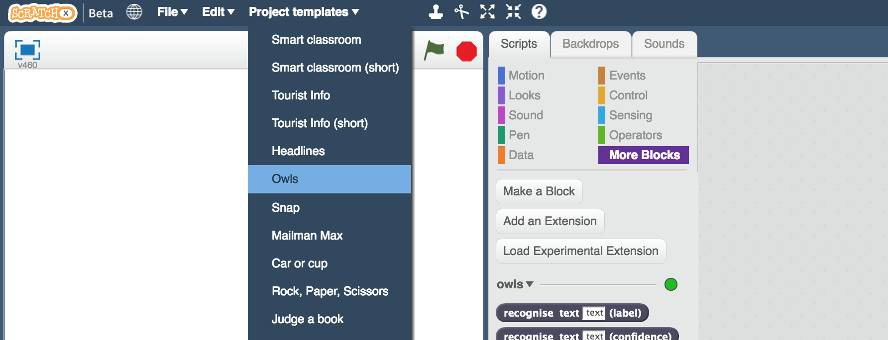

1. 拖曳程式積木（如下圖）

*確認你橘色的積木選擇的是“owl says”*

Create this little snippet of script but don’t attach it to anything yet  
*Make sure you choose “owl says” for the orange block.*   


1. 複製上面的積木四次

*點擊右鍵->複製*

Duplicate it four times  
*Right-click on it, and click “Duplicate”*   
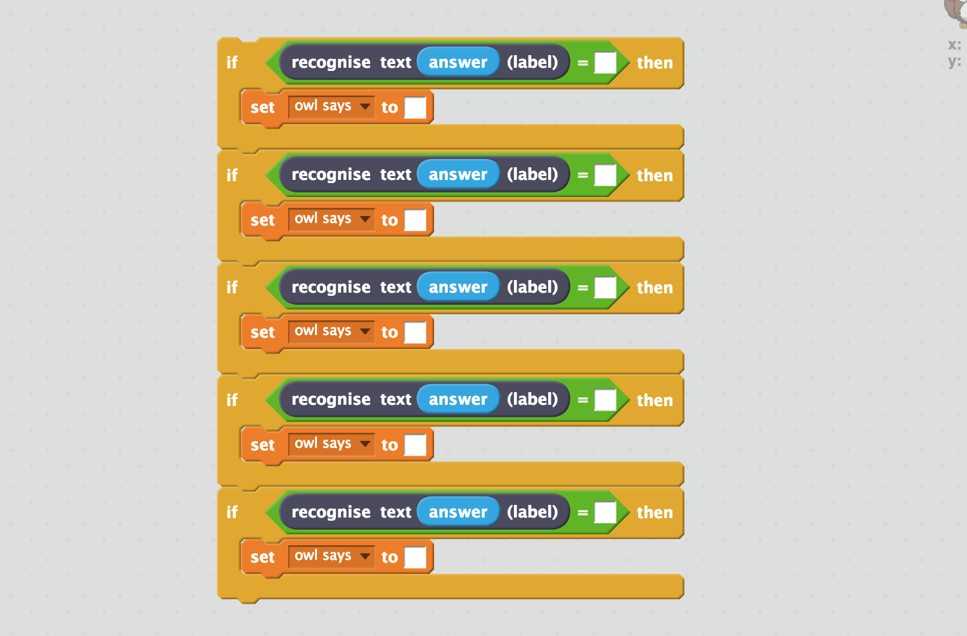

1. 填入對應的題目類別與回答

*綠色積木的地方放入題目類別的積木，下方橘色積木的地方輸入回答*

Fill in each copy of the block   
*Drag the label for one of your questions into the top space, and   
Type the answer to the question into the bottom space*  
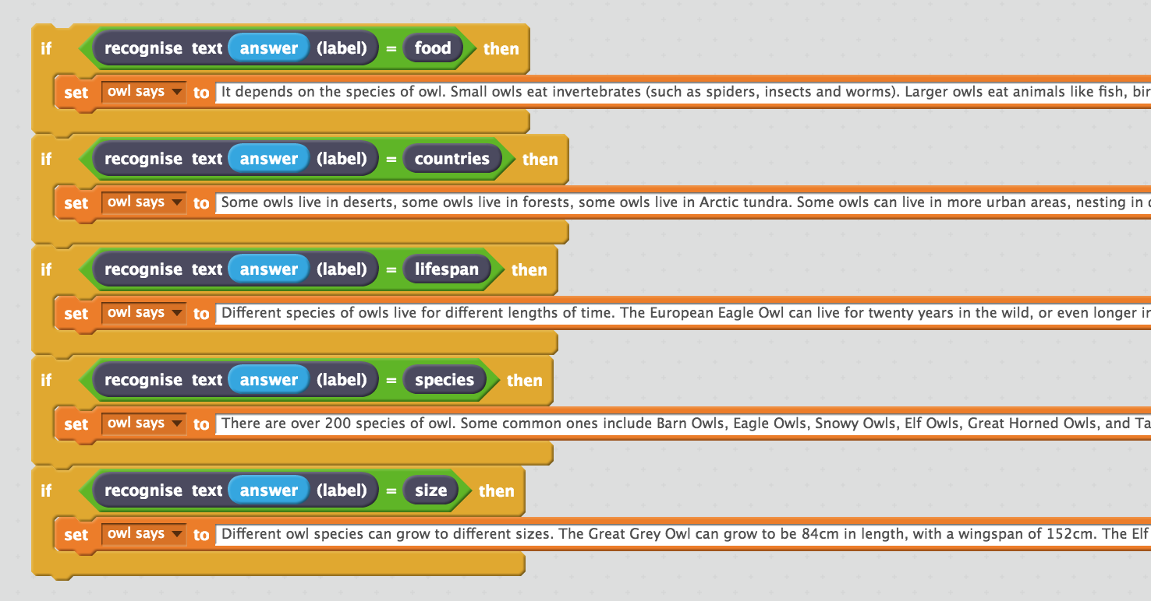

1. 一開始開啟專案時，你應該會發現程式區已經有個點擊綠旗的程式組，在完成上個步驟後，將你寫的積木放入原本的綠旗程式組，取代*“Sorry. I haven't been taught anything yet.”*

Drag this new block into the Green Flag block prepared for you.   
*Replace the “Sorry. I haven't been taught anything yet.” block with your new chunk of script.  
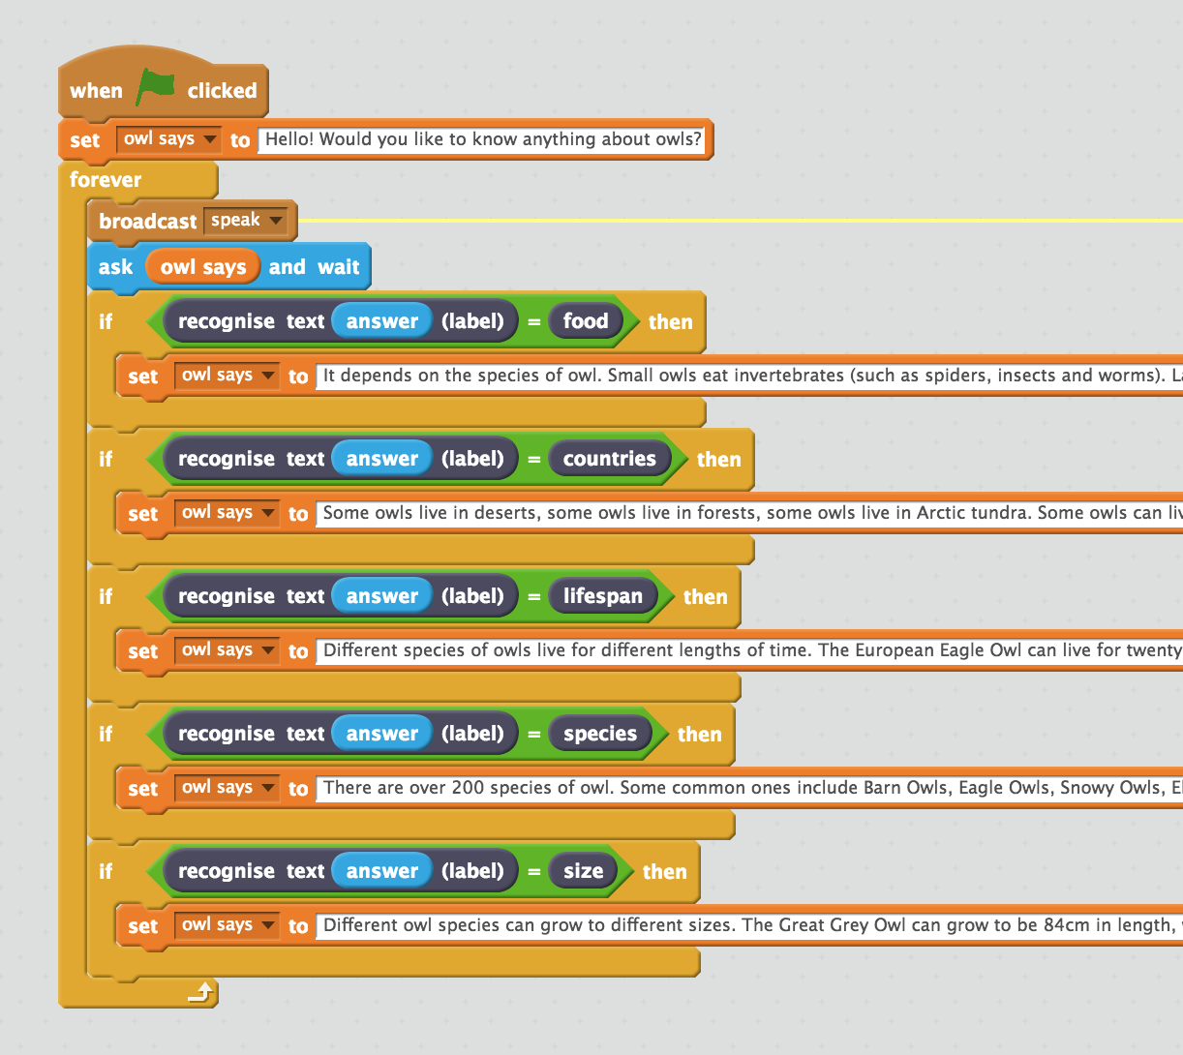*

1. 畫一隻屬於你的聊天機器人

*除非你也選貓頭鷹當主題，不然你就得自己畫啦。*

*你也可以幫你的聊天機器人設計不同的造型，讓他在說話時有不同的動作表情*

Draw your chatbot  
*Unless you’ve chosen* ***owls*** *as a topic, you’ll need to draw your own character  
If you provide different costumes, you can animate your character while it talks.   
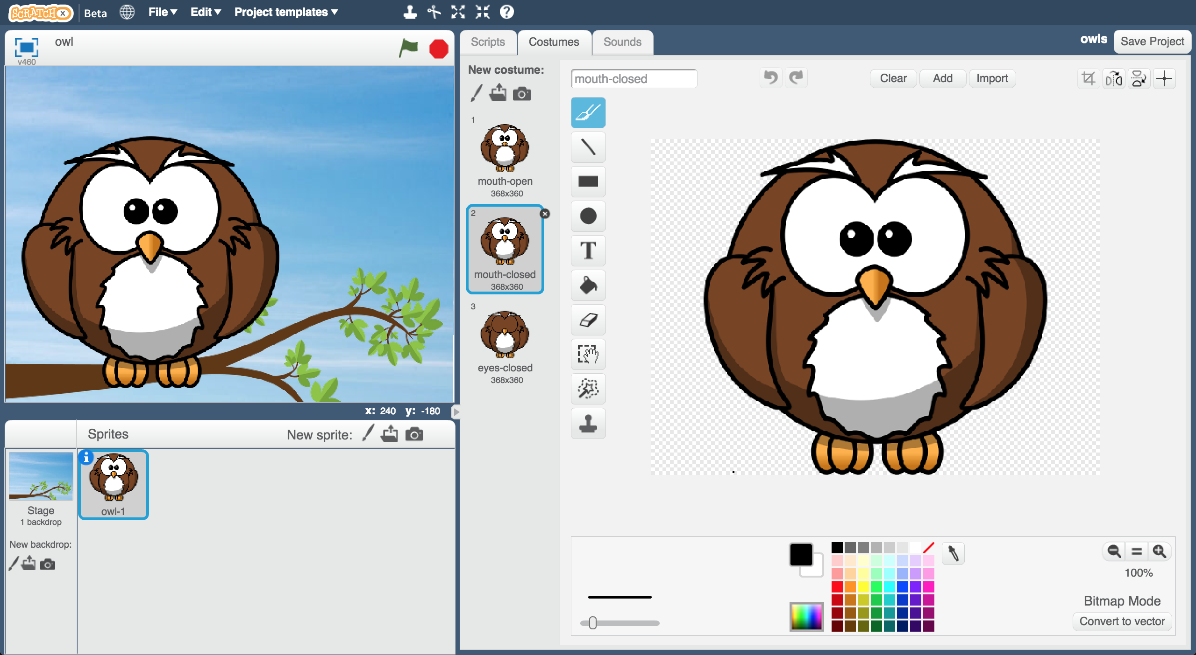*

1. 開始測試！

*點擊綠旗，開始問問題*

Test your chatbot!  
*Click the green flag and try asking the owl a question*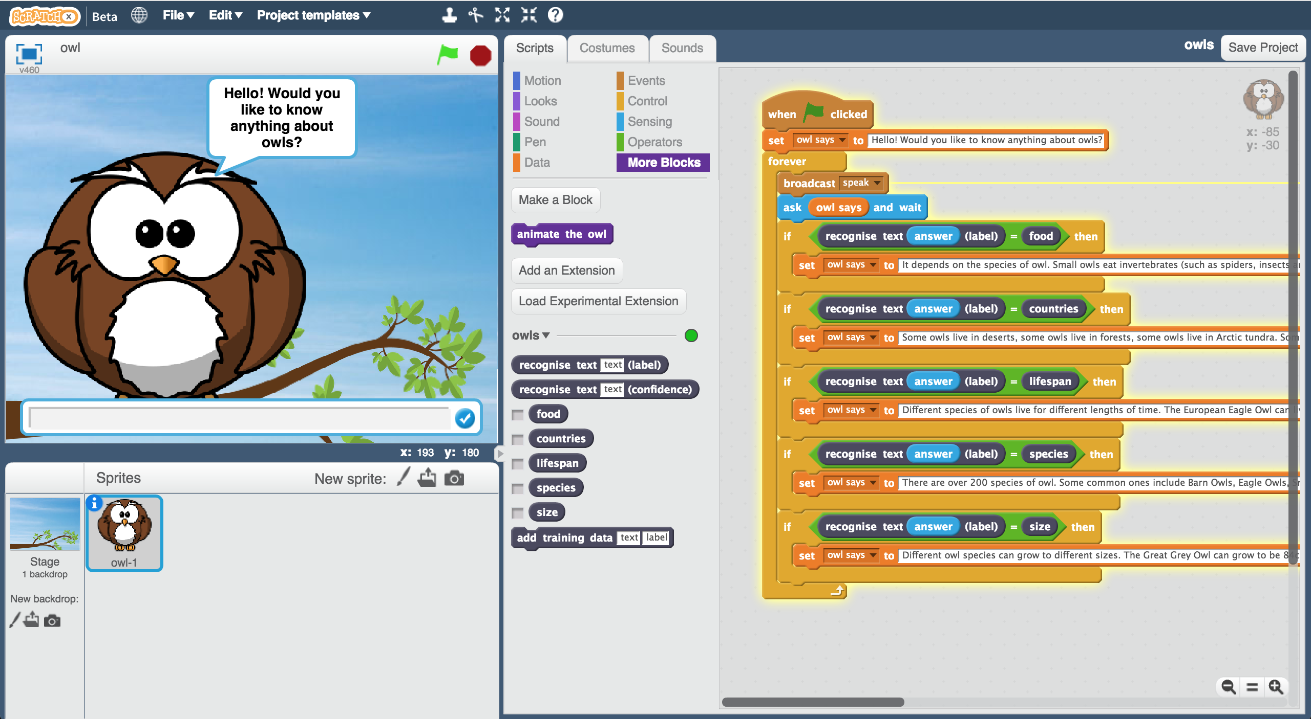

**你完成些什麼？**

**What have you done so far?**

你訓練電腦辨識在一個主題下的不同問題。但你不是採用制定規則的方式來訓練，而是使用蒐集範例的方式。這些蒐集來的範例會被用來訓練一個機器學習的 『模型』。

You’ve started to train a computer to recognise questions on a topic. Instead of trying to write rules to be able to do this, you did this by collecting examples. These examples were used to train a machine learning “model”.

這就是所謂的『監督式學習』(supervised learning)，因為你就像在監督電腦訓練一樣。

This is called “supervised learning” because of the way you are supervising the computer’s training.

電腦會從你給的範例中學習到一些模式，例如詞彙的選擇、句子的組成等，這些都會被用來辨別新的問題。

The computer will learn from patterns in the examples you’ve given it, such as the choice of words, and the way questions are structured. These will be used to be able to recognise new questions.

這最大的問題是如果你問他非預期的問題，他仍然會從先前給的答案中選一個來回答。

The biggest problem with this is that if you ask it something unexpected, it will still give you one of the answers you’ve written

1. 拖曳程式積木（如下圖），如果有人問到不是你步驟二的問題類別時，這些積木可以派上用場。

*信心分數(confidence score)是百分比的概念(0到100)，如果有人問的問題跟你用來訓練的範例很不像，那麼信心分數會變低*

Create this little chunk of script, that you can use when someone asks a question that wasn’t on your list from step 2.  
*The confidence score is a percentage (from 0 to 100).   
It will be lower if someone asks a question that isn’t similar to any of the examples you used to train the machine learning model.   
Use this to return a “I don’t understand” message if the score is too low.*   
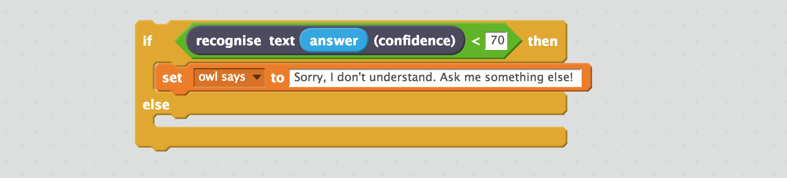

1. 將上面的積木加到原本的積木串裡

Add this into your script from before.   
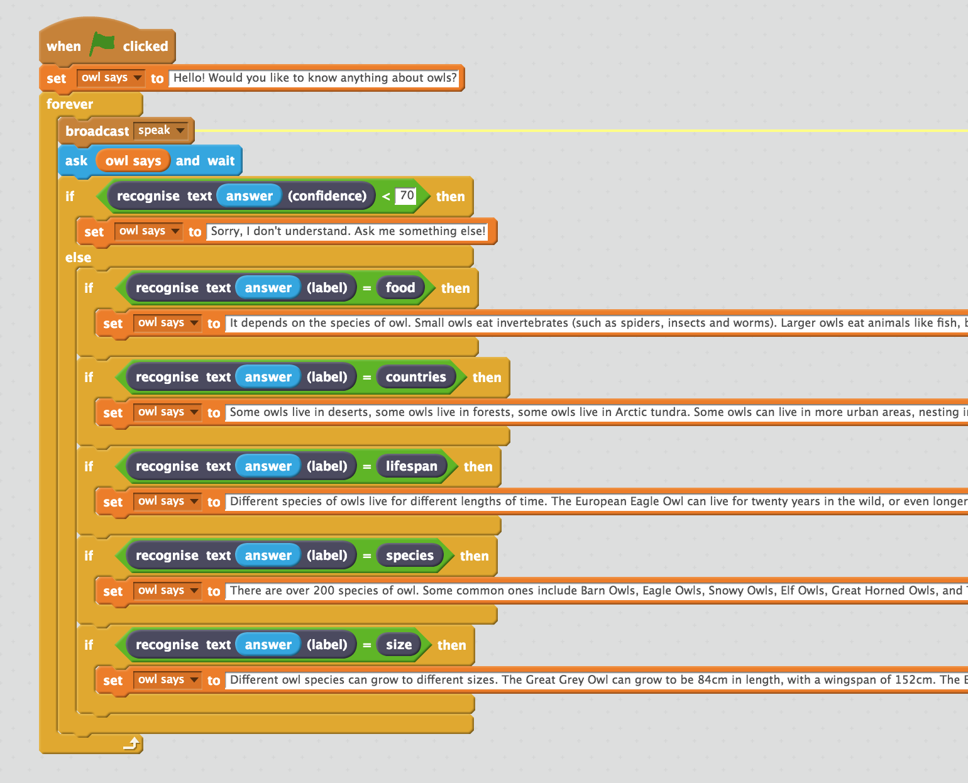

**延伸活動**

**Ideas and Extensions**

現在你已經完成了這個專案，要不要試試下面的點子？或者，自己想一個？

Now that you’ve finished, why not give one of these ideas a try?

Or come up with one of your own?

**試試其他的聊天機器人**

**Try other chatbots**

試試這個網站：<http://talktothetrex.com>，看能否從中得到改進你的聊天機器人的靈感。

<http://talktothetrex.com> is a good example of the sort of thing you’ve made. Give it a try and see if you can get any ideas of how to improve your bot.

**加入更多主題**

**Add more topics**

你能幫聊天機器人加入更多的主題嗎？這樣他就可以回答更多類型的問題了。

Can you add more topics to your chatbot, so that there are more types of question that it can answer?

**提供不同的回答**

**Provide alternate answers**

如果有個人問了不只一次相同的問題，那麼每次他都會得到相同的答案。

你能修改程式碼讓機器人每次回答都不一樣嗎？或者在回答問題之前先跟問問題的人說：你已經問過我這個問題囉(You’ve asked me this before) 。

If someone asks the same question more than once, they’ll get the exact same answer every time.

Can you update your Scratch script so that it varies the answers each time a little? Or just starts the answer with “You’ve asked me this before, but”

**這段我不知怎麼翻比較好**

**Ask follow-up questions**

Can you update your Scratch script so that it replies with a question? It can then recognise the answer to that question, in a similar way to how you made it recognise questions.